What is a Sorting Algorithm?
Sorting algorithms are a set of instructions that take an array or list as an input and arrange the items into a particular order.
Sorts are most commonly in numerical or a form of alphabetical (or lexicographical) order, and can be in ascending (A-Z, 0-9) or descending (Z-A, 9-0) order.

Why Sorting Algorithms are Important
Since they can often reduce the complexity of a problem, sorting algorithms are very important in computer science. These algorithms have direct applications in searching algorithms, database algorithms, divide and conquer methods, data structure algorithms, and many more.

Some Common Sorting Algorithms
Some of the most common sorting algorithms are:
- Selection sort
- Bubble sort
- Insertion sort
- Merge sort
- Quick sort
- Heap sort
- Selection Sort: Selection Sort is one of the simplest sorting algorithms. This algorithm gets its name from the way it iterates through the array: it selects the current smallest element, and swaps it into place.
Here's how it works:
Find the smallest element in the array and swap it with the first element.
Find the second smallest element and swap with with the second element in the array.
Find the third smallest element and swap wit with the third element in the array.
Repeat the process of finding the next smallest element and swapping it into the correct position until the entire array is sorted.
But, how would you write the code for finding the index of the second smallest value in an array?
An easy way is to notice that the smallest value has already been swapped into index 0, so the problem reduces to finding the smallest element in the array starting at index 1.
Selection sort always takes the same number of key comparisons — N(N − 1)/2
Properties
- Space Complexity: O(n)
- Time Complexity: O(n2)
- Sorting in Place: Yes
- Stable: No

- Bubble Sort:Just like the way bubbles rise from the bottom of a glass, bubble sort is a simple algorithm that sorts a list, allowing either lower or higher values to bubble up to the top. The algorithm traverses a list and compares adjacent values, swapping them if they are not in the correct order.
With a worst-case complexity of O(n^2), bubble sort is very slow compared to other sorting algorithms like quick sort. The upside is that it is one of the easiest sorting algorithms to understand and code from scratch.
From technical perspective, bubble sort is reasonable for sorting small-sized arrays or specially when executing sort algorithms on computers with remarkably limited memory resources.
Example:
First pass through the list:
Starting with [4, 2, 6, 3, 9], the algorithm compares the first two elements in the array, 4 and 2. It swaps them because 2 < 4: [2, 4, 6, 3, 9]
It compares the next two values, 4 and 6. As 4 < 6, these are already in order, and the algorithm moves on: [2, 4, 6, 3, 9]
The next two values are also swapped because 3 < 6: [2, 4, 3, 6, 9]
The last two values, 6 and 9, are already in order, so the algorithm does not swap them.
Second pass through the list:
2 < 4, so there is no need to swap positions: [2, 4, 3, 6, 9]
The algorithm swaps the next two values because 3 < 4: [2, 3, 4, 6, 9]
No swap as 4 < 6: [2, 3, 4, 6, 9]
Again, 6 < 9, so no swap occurs: [2, 3, 4, 6, 9]
The list is already sorted, but the bubble sort algorithm doesn't realize this. Rather, it needs to complete an entire pass through the list without swapping any values to know the list is sorted.
Third pass through the list:
[2, 4, 3, 6, 9] => [2, 4, 3, 6, 9]
[2, 4, 3, 6, 9] => [2, 4, 3, 6, 9]
[2, 4, 3, 6, 9] => [2, 4, 3, 6, 9]
[2, 4, 3, 6, 9] => [2, 4, 3, 6, 9]
Clearly bubble sort is far from the most efficient sorting algorithm. Still, it's simple to wrap your head around and implement yourself.
Properties
- Space complexity: O(1)
- Best case performance: O(n)
- Average case performance: O(n*n)
- Worst case performance: O(n*n)
- Stable: Yes
- Insertion Sort: Insertion sort is a simple sorting algorithm for a small number of elements.
Example:
In Insertion sort, you compare the key element with the previous elements. If the previous elements are greater than the key element, then you move the previous element to the next position.
Start from index 1 to size of the input array.
[ 8 3 5 1 4 2 ]
Step 1 :
key = 3 //starting from 1st index.
Here `key` will be compared with the previous elements.
In this case, `key` is compared with 8. since 8 > 3, move the element 8
to the next position and insert `key` to the previous position.
Result: [ 3 8 5 1 4 2 ]
Step 2 :

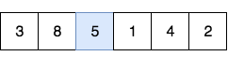
key = 5 //2nd index
8 > 5 //move 8 to 2nd index and insert 5 to the 1st index.
Result: [ 3 5 8 1 4 2 ]
Step 3 :

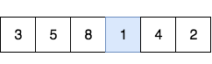
key = 1 //3rd index
8 > 1 => [ 3 5 1 8 4 2 ]
5 > 1 => [ 3 1 5 8 4 2 ]
3 > 1 => [ 1 3 5 8 4 2 ]
Result: [ 1 3 5 8 4 2 ]
Step 4 :
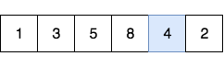
key = 4 //4th index
8 > 4 => [ 1 3 5 4 8 2 ]
5 > 4 => [ 1 3 4 5 8 2 ]
3 > 4 ≠> stop
Result: [ 1 3 4 5 8 2 ]
Step 5 :
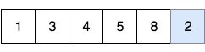
key = 2 //5th index
8 > 2 => [ 1 3 4 5 2 8 ]
5 > 2 => [ 1 3 4 2 5 8 ]
4 > 2 => [ 1 3 2 4 5 8 ]
3 > 2 => [ 1 2 3 4 5 8 ]
1 > 2 ≠> stop
Result: [1 2 3 4 5 8]
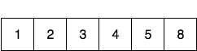
The algorithm shown below is a slightly optimized version to avoid swapping the key element in every iteration. Here, the key element will be swapped at the end of the iteration (step).
InsertionSort(arr[])
for j = 1 to arr.length
key = arr[j]
i = j - 1
while i > 0 and arr[i] > key
arr[i+1] = arr[i] i = i - 1
arr[i+1] = key
Properties:
- Space Complexity: O(1)
- Time Complexity: O(n), O(n* n), O(n* n) for Best, Average, Worst cases respectively.
- Best Case: array is already sorted
- Average Case: array is randomly sorted
- Worst Case: array is reversely sorted.
- Sorting In Place: Yes
- Stable: Yes

- Merge Sort: Merge Sort is a Divide and Conquer algorithm. It divides input array in two halves, calls itself for the two halves and then merges the two sorted halves. The major portion of the algorithm is given two sorted arrays, and we have to merge them into a single sorted array. The whole process of sorting an array of N integers can be summarized into three steps-
Divide the array into two halves.
Sort the left half and the right half using the same recurring algorithm.
Merge the sorted halves.
There is something known as the Two Finger Algorithm that helps us merge two sorted arrays together. Using this subroutine and calling the merge sort function on the array halves recursively will give us the final sorted array we are looking for.
Since this is a recursion based algorithm, we have a recurrence relation for it. A recurrence relation is simply a way of representing a problem in terms of its subproblems.
T(n) = 2 * T(n / 2) + O(n)
Putting it in plain English, we break down the subproblem into two parts at every step and we have some linear amount of work that we have to do for merging the two sorted halves together at each step.
Complexity
The biggest advantage of using Merge sort is that the time complexity is only n*log(n) to sort an entire Array. It is a lot better than n^2 running time of bubble sort or insertion sort.
Before we write code, let us understand how merge sort works with the help of a diagram.
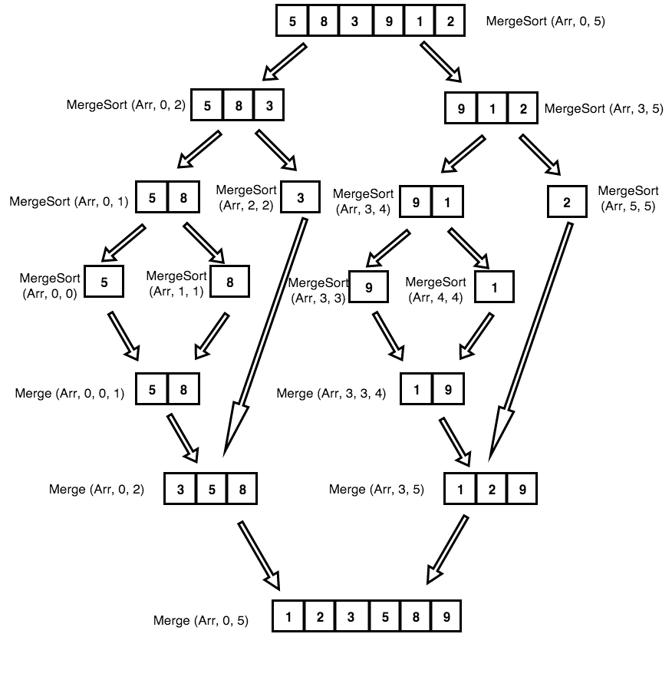
- Initially we have an array of 6 unsorted integers Arr(5, 8, 3, 9, 1, 2)
- We split the array into two halves Arr1 = (5, 8, 3) and Arr2 = (9, 1, 2).
- Again, we divide them into two halves: Arr3 = (5, 8) and Arr4 = (3) and Arr5 = (9, 1) and Arr6 = (2)
- Again, we divide them into two halves: Arr7 = (5), Arr8 = (8), Arr9 = (9), Arr10 = (1) and Arr6 = (2)
- We will now compare the elements in these sub arrays in order to merge them.
Properties:
- Space Complexity: O(n)
- Time Complexity: O(n*log(n)). The time complexity for the Merge Sort might not be obvious from the first glance. The log(n) factor that comes in is because of the recurrence relation we have mentioned before.
- Sorting In Place: No in a typical implementation
- Stable: Yes
- Parallelizable: yes (Several parallel variants are discussed in the third edition of Cormen, Leiserson, Rivest, and Stein's Introduction to Algorithms.)

- Quick Sort: Quick sort is an efficient divide and conquer sorting algorithm. Average case time complexity of Quick Sort is O(nlog(n)) with worst case time complexity being O(n^2) depending on the selection of the pivot element, which divides the current array into two sub arrays.
For instance, the time complexity of Quick Sort is approximately O(nlog(n)) when the selection of pivot divides original array into two nearly equal sized sub arrays.
On the other hand, if the algorithm, which selects of pivot element of the input arrays, consistently outputs 2 sub arrays with a large difference in terms of array sizes, quick sort algorithm can achieve the worst case time complexity of O(n^2).
The steps involved in Quick Sort are:
- Choose an element to serve as a pivot, in this case, the last element of the array is the pivot.
- Partitioning: Sort the array in such a manner that all elements less than the pivot are to the left, and all elements greater than the pivot are to the right.
- Call Quick sort recursively, taking into account the previous pivot to properly subdivide the left and right arrays. (A more detailed explanation can be found in the comments below)
The space complexity of quick sort is O(n). This is an improvement over other divide and conquer sorting algorithms, which take O(nlong(n)) space.
Quick sort achieves this by changing the order of elements within the given array. Compare this with the merge sort algorithm which creates 2 arrays, each length n/2, in each function call.
However there does exist the problem of this sorting algorithm being of time O(n*n) if the pivot is always kept at the middle. This can be overcomed by utilizing a random pivot
Complexity
Best, average, worst, memory: n log(n)n log(n)n 2log(n). It's not a stable algorithm, and quicksort is usually done in-place with O(log(n)) stack space.
The space complexity of quick sort is O(n). This is an improvement over other divide and conquer sorting algorithms, which take O(n log(n)) space.
- Heap sort: It is an efficient sorting algorithm based on the use of max/min heaps. A heap is a tree-based data structure that satisfies the heap property – that is for a max heap, the key of any node is less than or equal to the key of its parent (if it has a parent).
This property can be leveraged to access the maximum element in the heap in O(logn) time using the maxHeapify method. We perform this operation n times, each time moving the maximum element in the heap to the top of the heap and extracting it from the heap and into a sorted array. Thus, after n iterations we will have a sorted version of the input array.
The algorithm is not an in-place algorithm and would require a heap data structure to be constructed first. The algorithm is also unstable, which means when comparing objects with same key, the original ordering would not be preserved.
This algorithm runs in O(nlogn) time and O(1) additional space [O(n) including the space required to store the input data] since all operations are performed entirely in-place.
The best, worst and average case time complexity of Heapsort is O(nlogn). Although heapsort has a better worse-case complexity than quick sort, a well-implemented quicksort runs faster in practice. This is a comparison-based algorithm so it can be used for non-numerical data sets insofar as some relation (heap property) can be defined over the elements.

Implementation in C/C++

Selection Sort
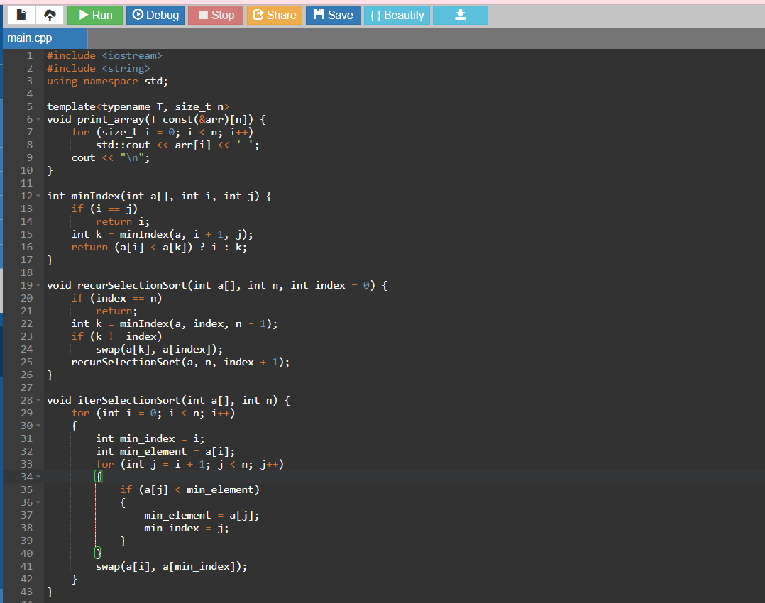
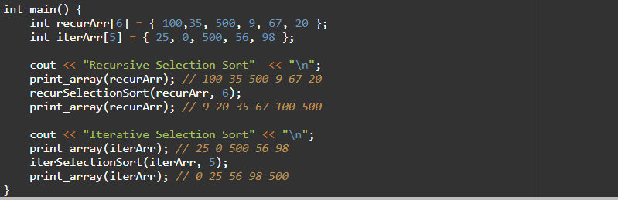
OUTPUT:
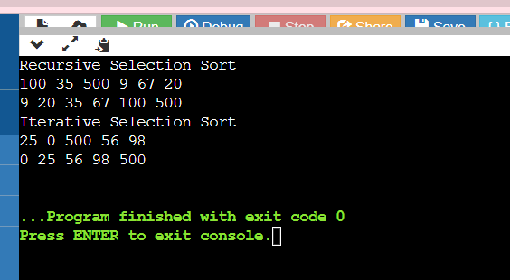

Bubble Sort
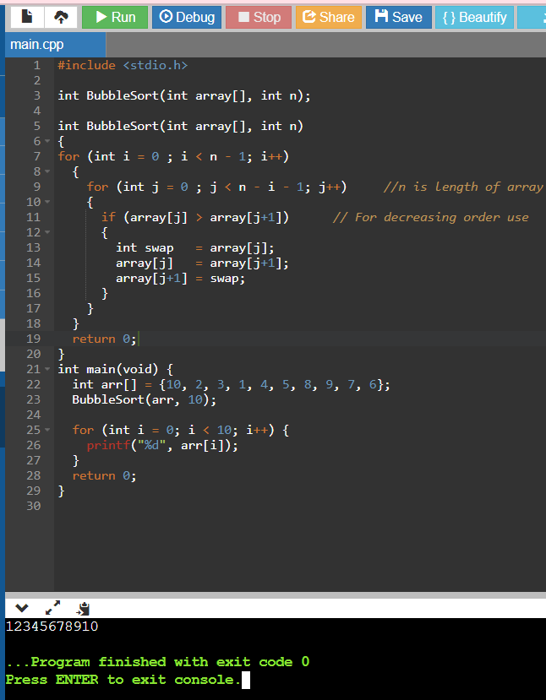

Insertion Sort
void insertionSort(int arr[], int n) {
int i, key, j;
for (i = 1; i < n; i++)
{
key = arr[i];
j = i-1;
while (j >= 0 && arr[j] > key)
{
arr[j+1] = arr[j];
j = j-1;
}
arr[j+1] = key;
} }

Merge Sort
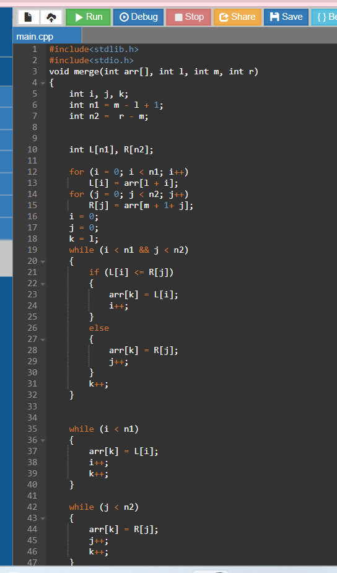
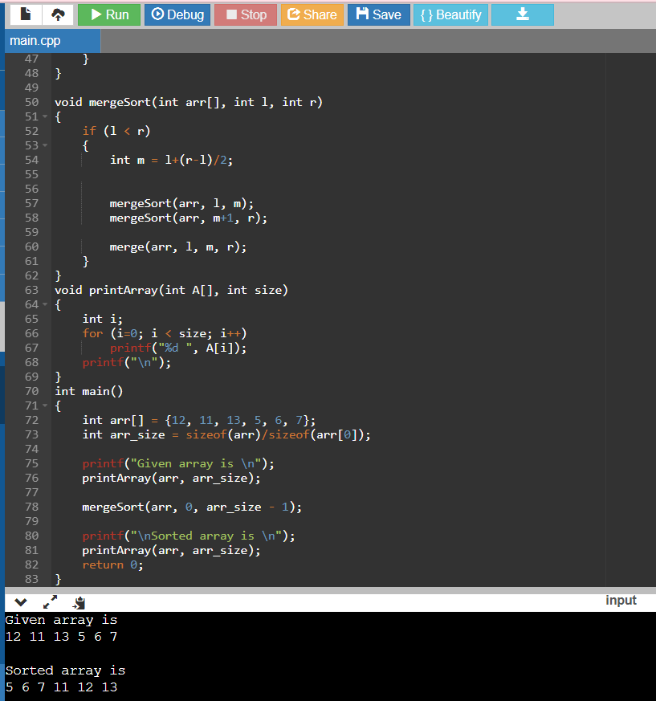

Quick Sort
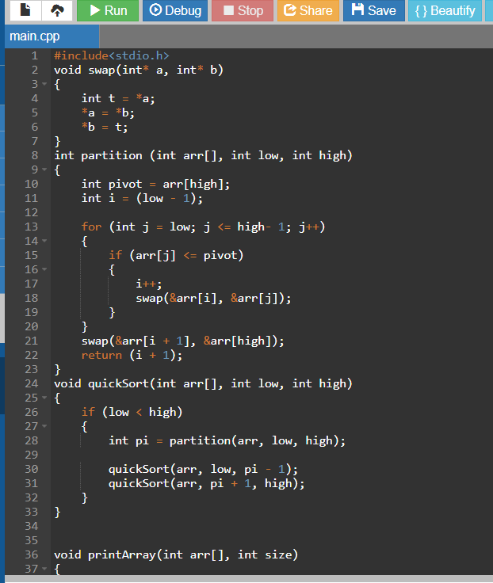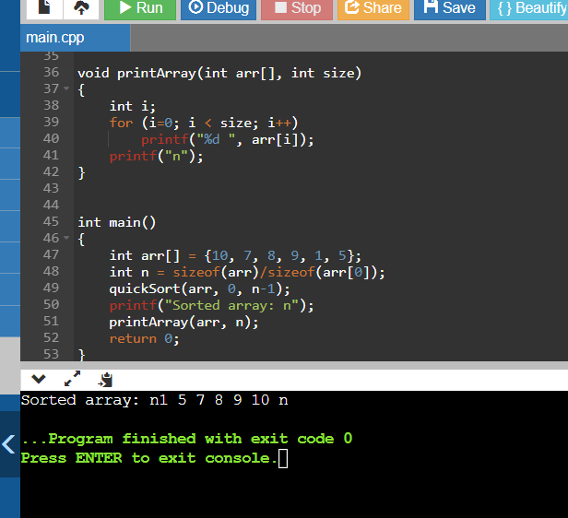

Heap Sort
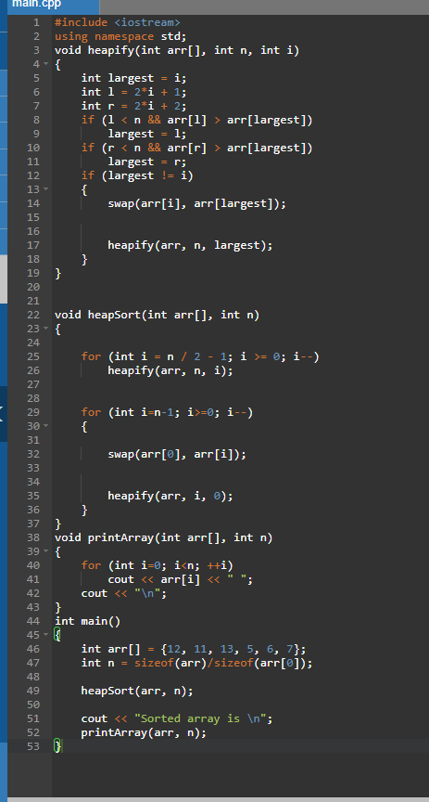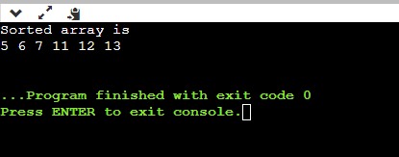
An Empirical Comparison of Sorting Algorithms
Which sorting algorithm is fastest? Asymptotic complexity analysis lets us distinguish between Θ(n2)Θ(n2) and Θ(nlogn)Θ(nlog⁡n) algorithms, but it does not help distinguish between algorithms with the same asymptotic complexity. Nor does asymptotic analysis say anything about which algorithm is best for sorting small lists. For answers to these questions, we can turn to empirical testing.
Table:
Sort | 10 | 100 | 1K | 10K | 100K | 1M | Up | Down
Insertion | 0.00023 | 0.007 | 0.66 | 64.98 | 7381.0 | 674420 | 0.04 | 129.05
Bubble | 0.00035 | 0.020 | 2.25 | 277.94 | 27691.0 | 2820680 | 70.64 | 108.69
Selection | 0.00039 | 0.12 | 0.69 | 72.47 | 7356.0 | 780000 | 69.76 | 69.58
Merge | 0.00050 | 0.10 | 0.12 | 1.61 | 19.3 | 219 | 0.83 | 0.79
Quick | 0.00048 | 0.08 | 0.11 | 1.37 | 15.7 | 162 | 0.47 | 0.66
Heap | 0.00050 | 0.11 | 0.16 | 2.08 | 26.7 | 391.0 | 1.57 | 1.56

